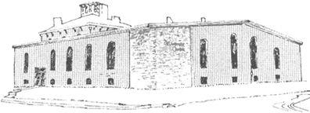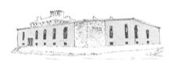

**The Deliverance Center**

Pastor James Reynolds, Sr.

Asst. Pastor Stephen G. Reynolds, Sr.

1008 Congress St. Portland, ME 04102

Tel. (207) 774-8192

[www.**thedeliverancecenter**.com](http://www.thedeliverancecenter.com)

*From the Desk of Pastor Stephen Reynolds, Sr.*

To whom it may concern:

**FMC Cadd** on Preble Street

1. Will you draw up scaled floor plans for the necessary parts of the building?
2. Will you work with us to call out fire door assembly and fire wall locations and door schedules?

Sincerely,

Stephen G. Reynolds, Sr.

Assistant Pastor